**Ideation Phase**

**Define the Problem Statements**

|  |  |
| --- | --- |
| Date | 19 September 2022 |
| Team ID | PNT2022TMID40129 |
| Project Name | Project – Personal Assistance for seniors who are self reliant |
| Maximum Marks | 2 Marks |

**Example:**

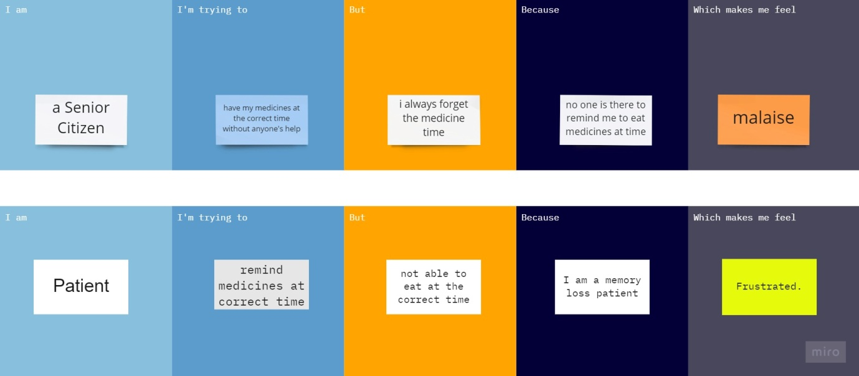

|  |  |  |  |  |  |
| --- | --- | --- | --- | --- | --- |
| **Problem Statement (PS)** | **Iam (Customer)** | **I’m trying to** | **But** | **Because** | **Which makes me feel** |
| PS-1 | A senior citizen | have my medicines at the correct time without anyone's help | i always forget the medicine time | no one is there to remind me to eat medicines at time | malaise |
| PS-2 | Patient | remind medicines at correct time | not able to eat at the correct time | I am a memory loss patient | Frustrated. |

Reference: <https://miro.com/welcomeonboard/Rlk0U0xlbVB3bm1Xcms5bjJ4dFhJMVRSWFBvTE1KdlhaeXAzZnZjOTQwVHZCSVl5eWhseDJrRGVXNUdUZWUwZHwzNDU4NzY0NTM2ODE4OTg4MjE5fDI=?share_link_id=577382181457>